Part 1 Data flow diagram

[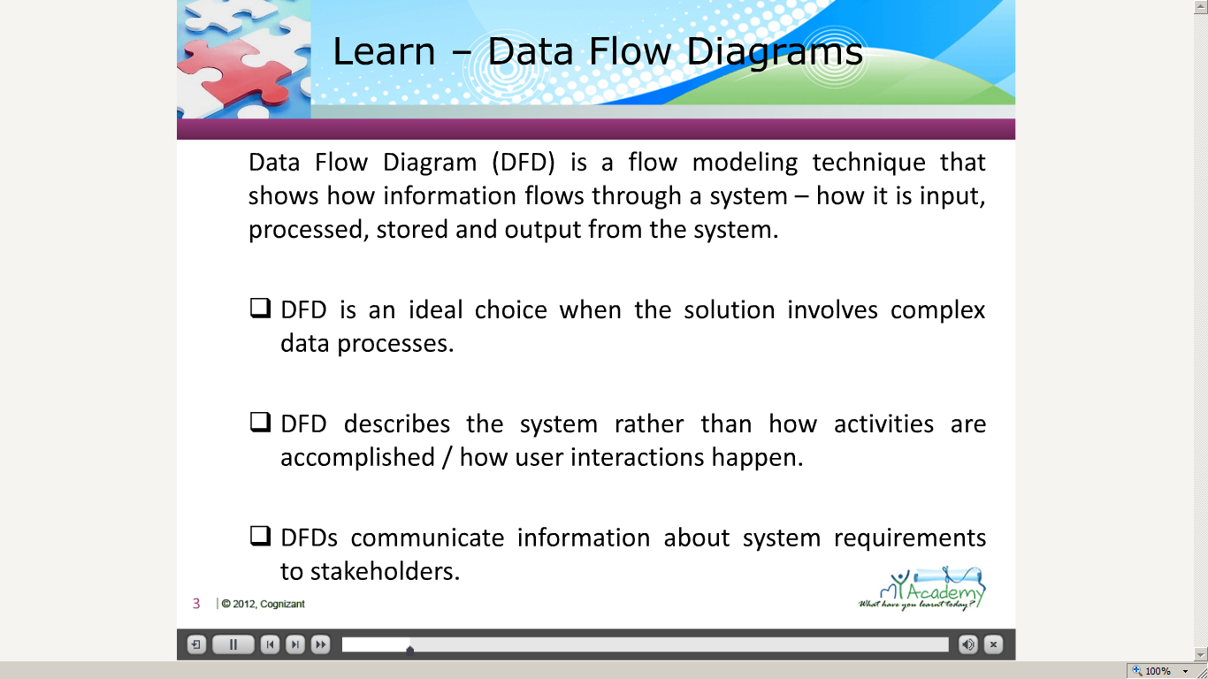](https://compass.learning.cognizant.com/elmprd/elearning/dataflowdiagram_basiclearning_practioner/dataflowdiagram_basiclearning_practitioner.htm)

[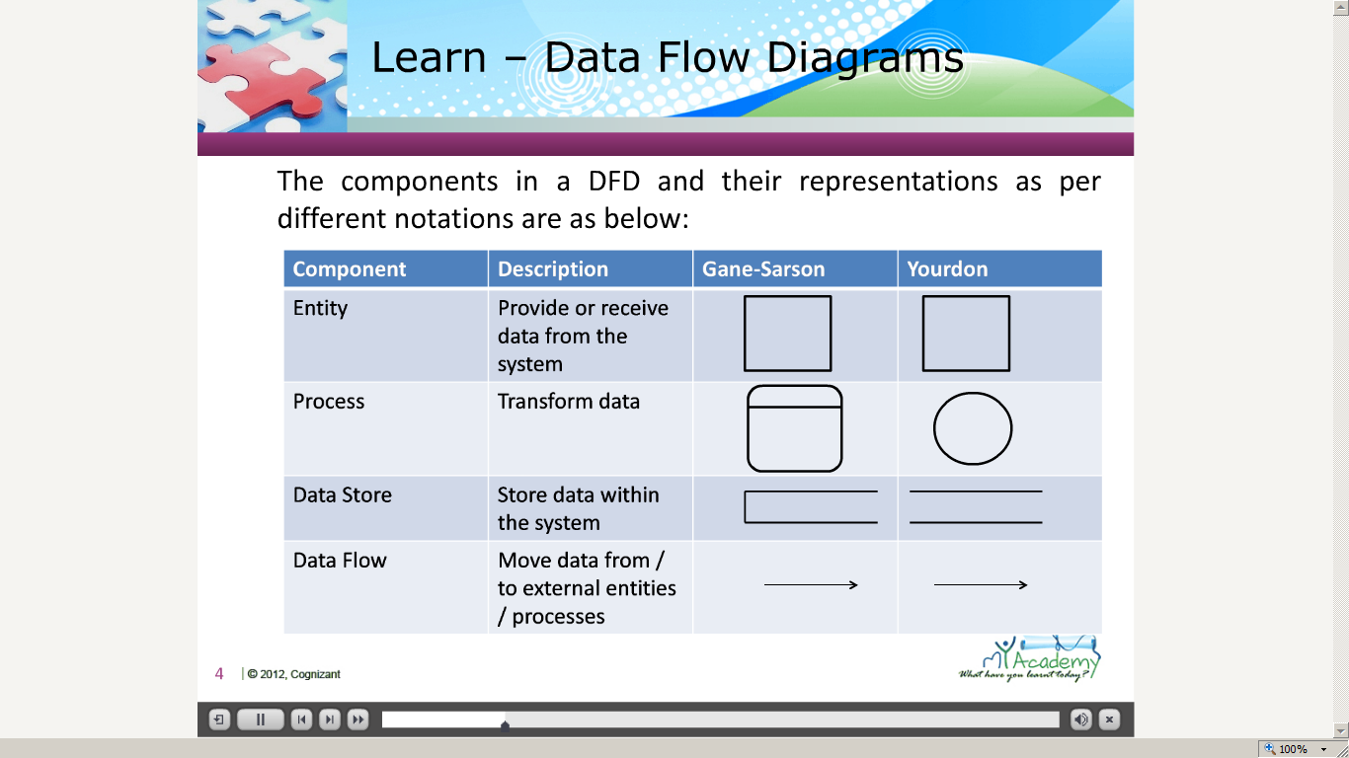](https://compass.learning.cognizant.com/elmprd/elearning/dataflowdiagram_basiclearning_practioner/dataflowdiagram_basiclearning_practitioner.htm)

[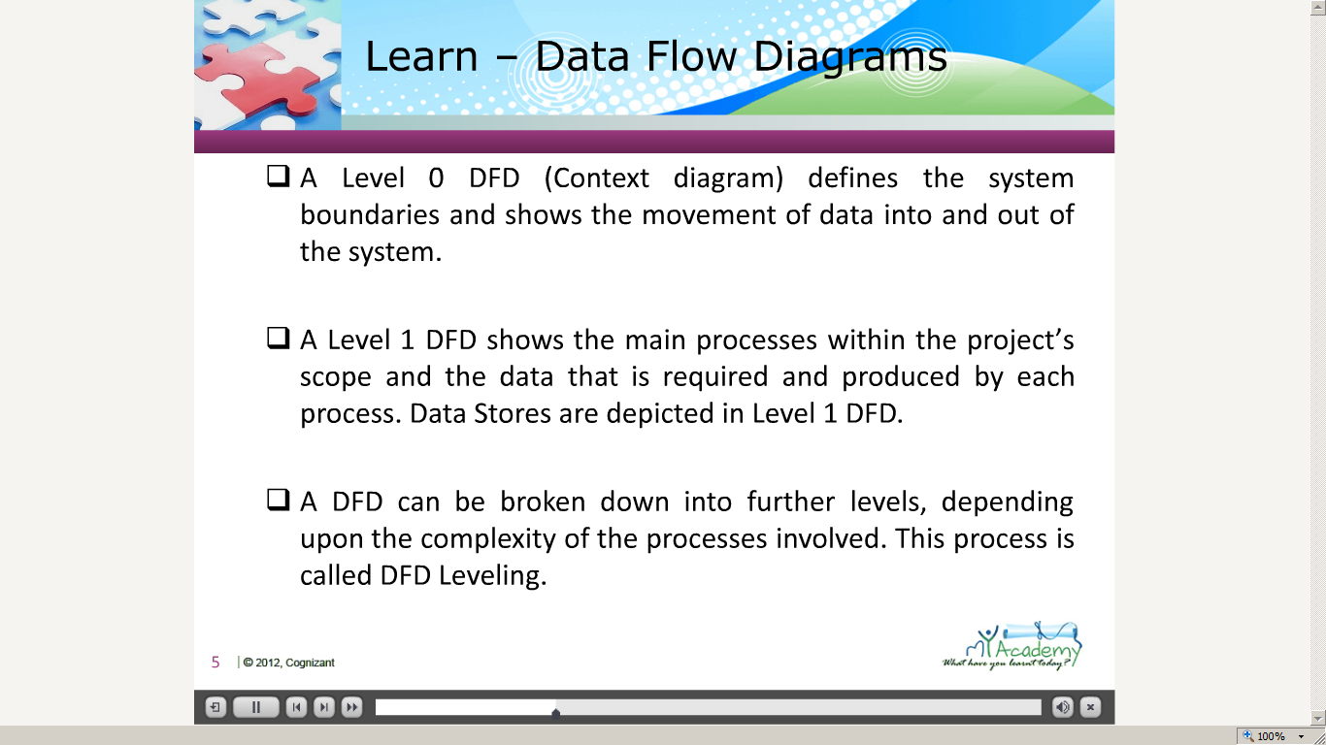](https://compass.learning.cognizant.com/elmprd/elearning/dataflowdiagram_basiclearning_practioner/dataflowdiagram_basiclearning_practitioner.htm)

[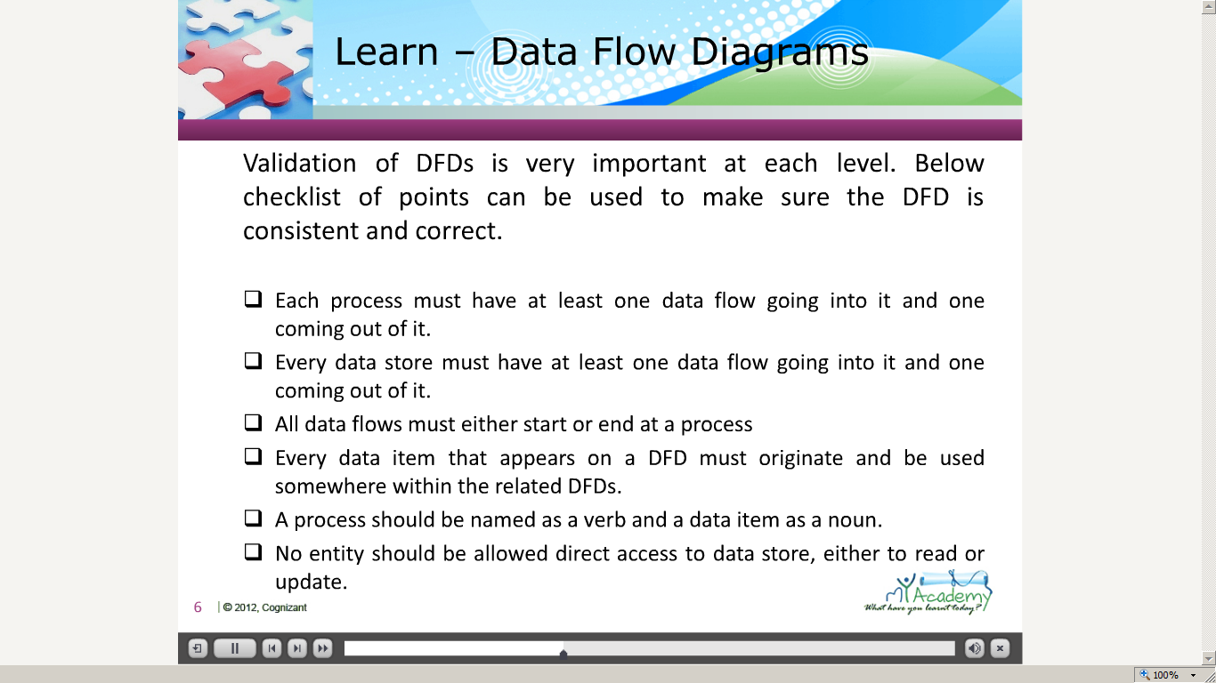](https://compass.learning.cognizant.com/elmprd/elearning/dataflowdiagram_basiclearning_practioner/dataflowdiagram_basiclearning_practitioner.htm)

[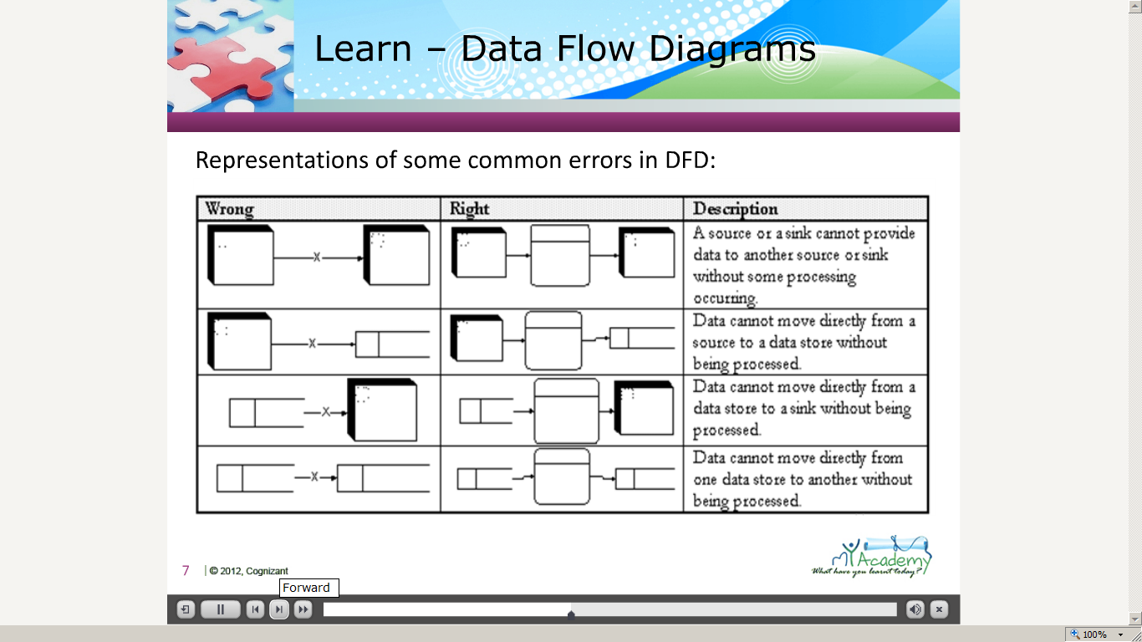](https://compass.learning.cognizant.com/elmprd/elearning/dataflowdiagram_basiclearning_practioner/dataflowdiagram_basiclearning_practitioner.htm)

[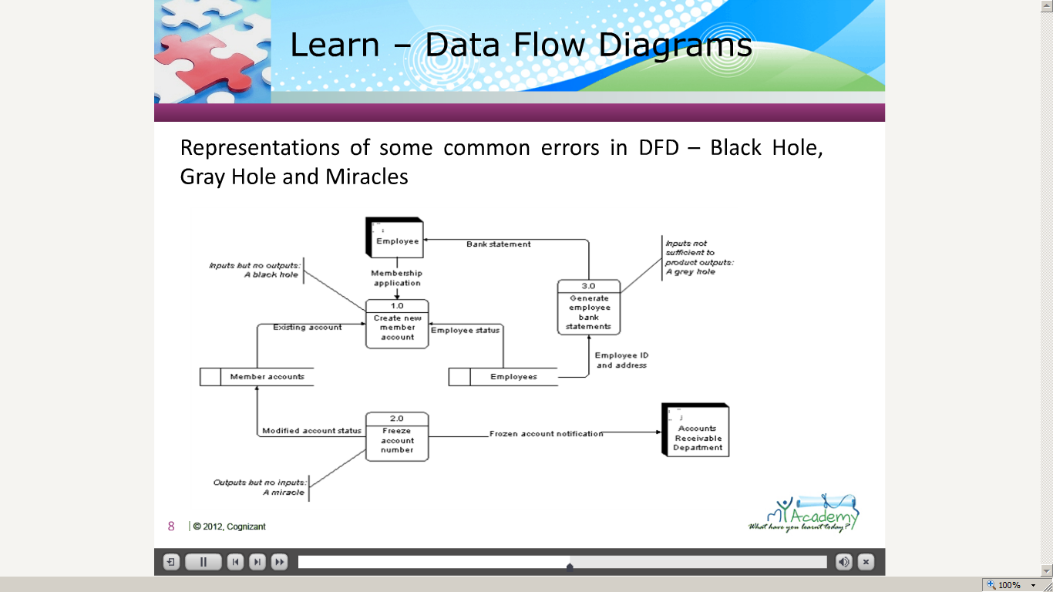](https://compass.learning.cognizant.com/elmprd/elearning/dataflowdiagram_basiclearning_practioner/dataflowdiagram_basiclearning_practitioner.htm)

[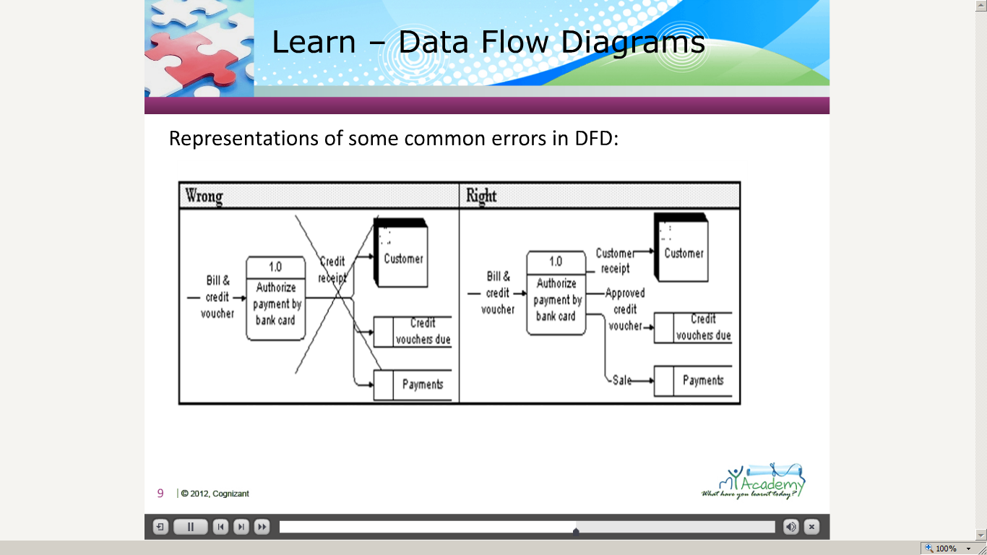](https://compass.learning.cognizant.com/elmprd/elearning/dataflowdiagram_basiclearning_practioner/dataflowdiagram_basiclearning_practitioner.htm)

[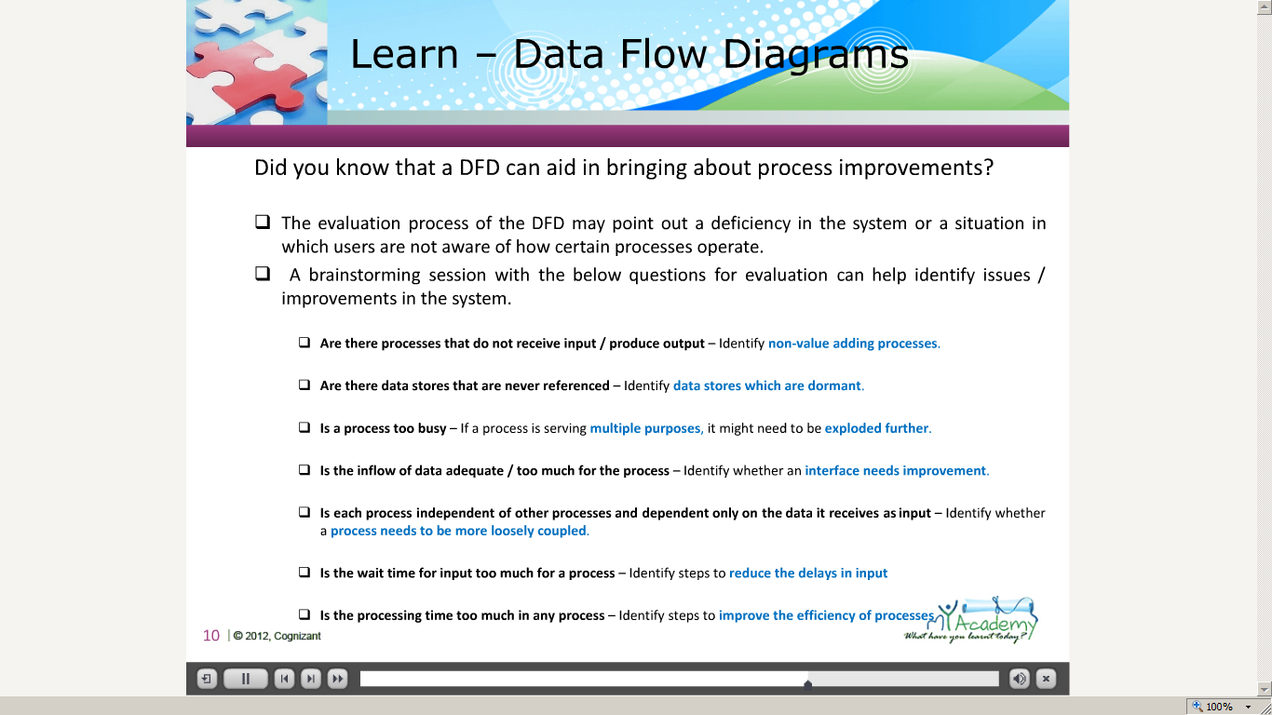](https://compass.learning.cognizant.com/elmprd/elearning/dataflowdiagram_basiclearning_practioner/dataflowdiagram_basiclearning_practitioner.htm)

[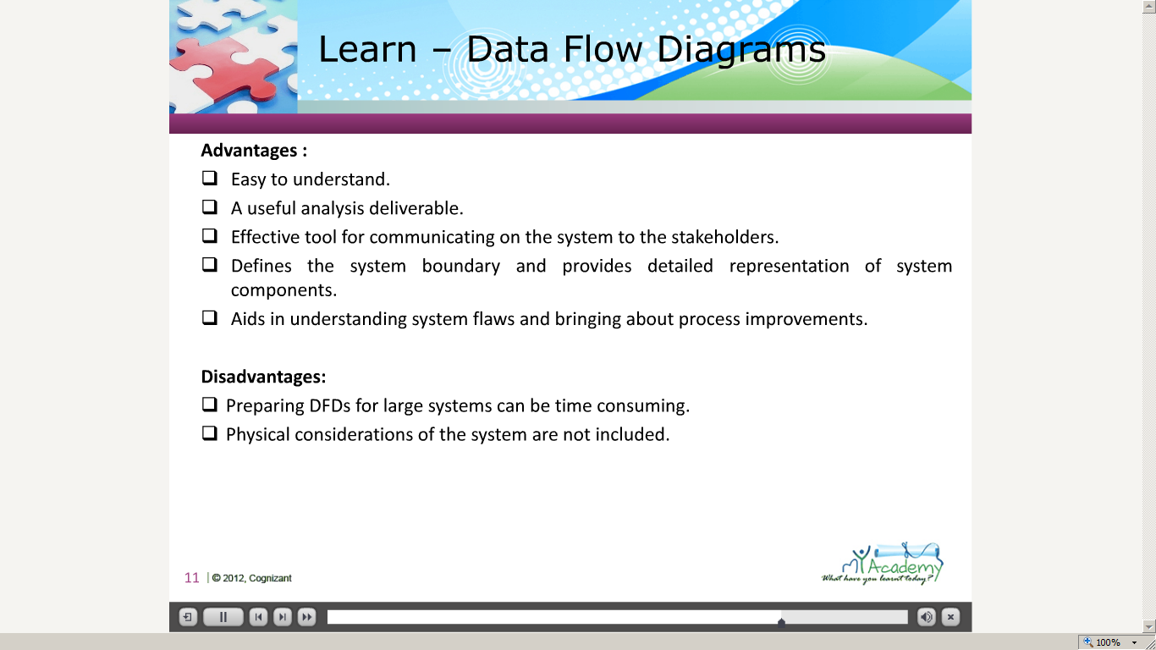](https://compass.learning.cognizant.com/elmprd/elearning/dataflowdiagram_basiclearning_practioner/dataflowdiagram_basiclearning_practitioner.htm)

Part 2 Case study

[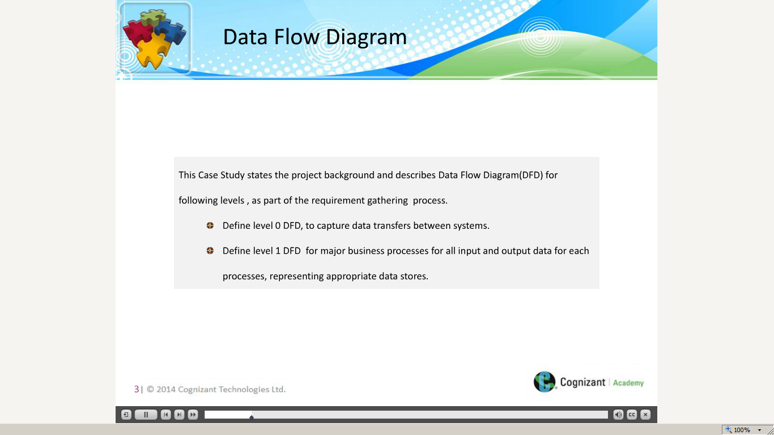](https://compass.learning.cognizant.com/elmprd/elearning/dfd_casestudy_practitioner/multiscreen.html)

[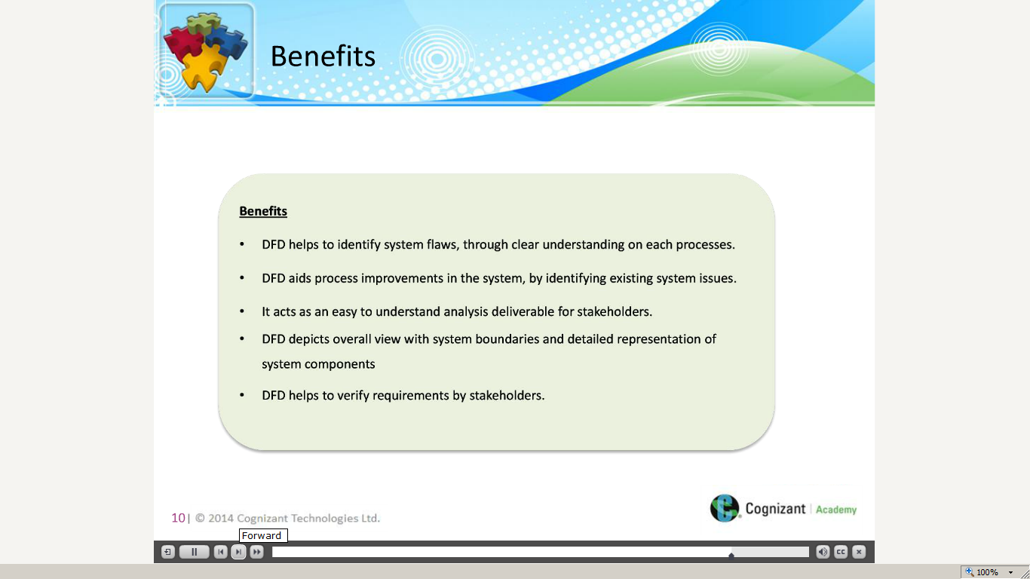](https://compass.learning.cognizant.com/elmprd/elearning/dfd_casestudy_practitioner/multiscreen.html)

Part 3 Data flow diagram quiz

[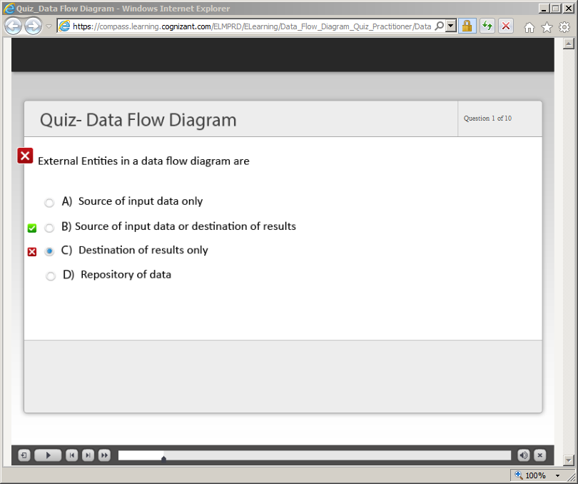](https://compass.learning.cognizant.com/elmprd/elearning/data_flow_diagram_quiz_practitioner/data%20flow%20diagram_quiz_practitioner.htm)

[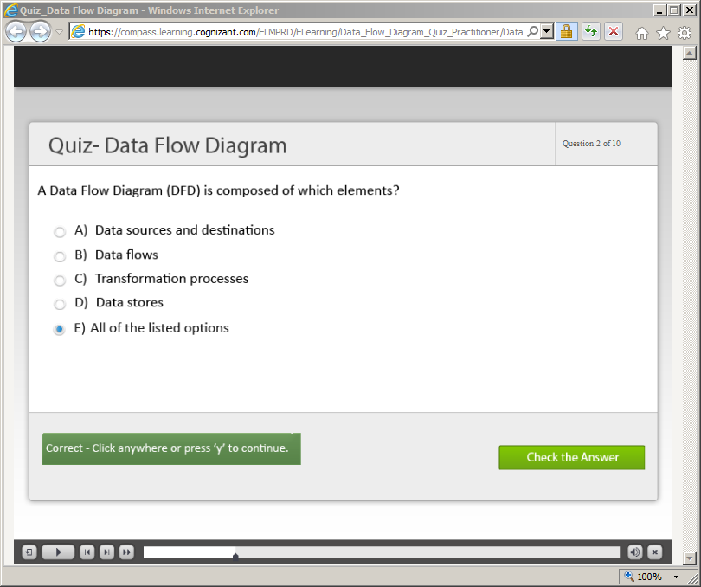](https://compass.learning.cognizant.com/elmprd/elearning/data_flow_diagram_quiz_practitioner/data%20flow%20diagram_quiz_practitioner.htm)

[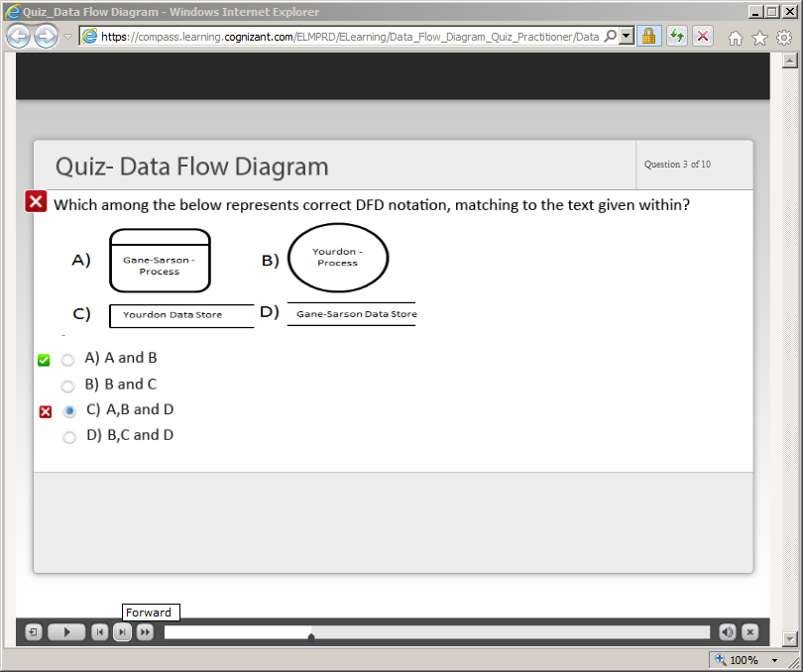](https://compass.learning.cognizant.com/elmprd/elearning/data_flow_diagram_quiz_practitioner/data%20flow%20diagram_quiz_practitioner.htm)

[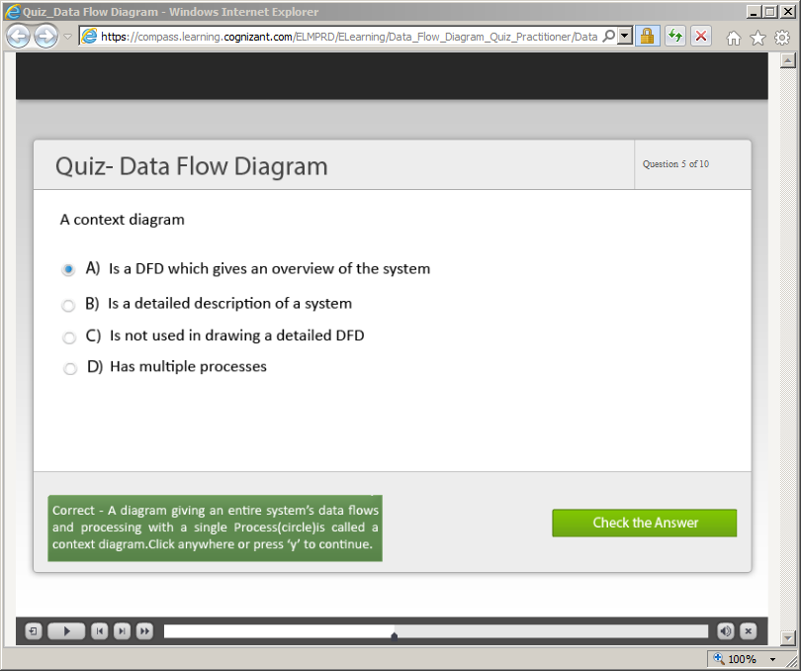](https://compass.learning.cognizant.com/elmprd/elearning/data_flow_diagram_quiz_practitioner/data%20flow%20diagram_quiz_practitioner.htm)

[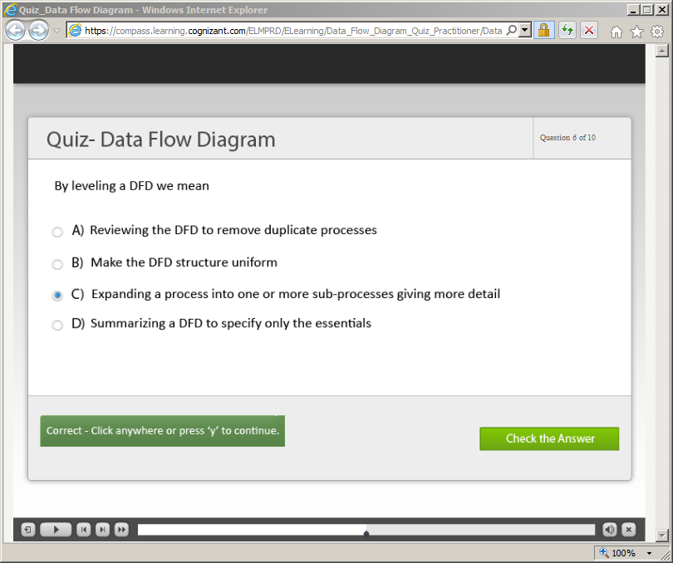](https://compass.learning.cognizant.com/elmprd/elearning/data_flow_diagram_quiz_practitioner/data%20flow%20diagram_quiz_practitioner.htm)

[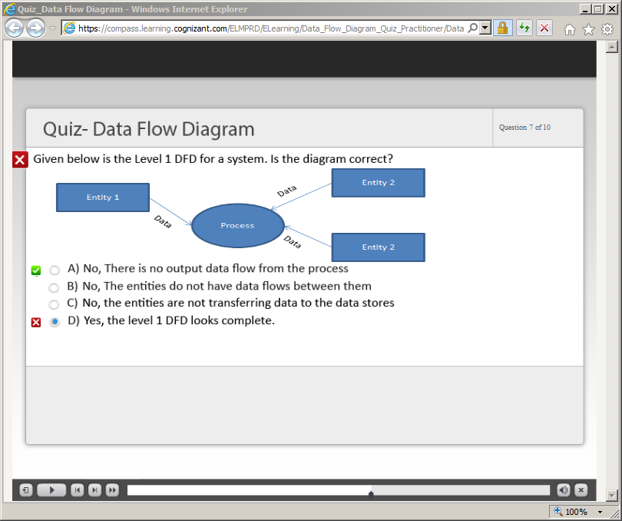](https://compass.learning.cognizant.com/elmprd/elearning/data_flow_diagram_quiz_practitioner/data%20flow%20diagram_quiz_practitioner.htm)

[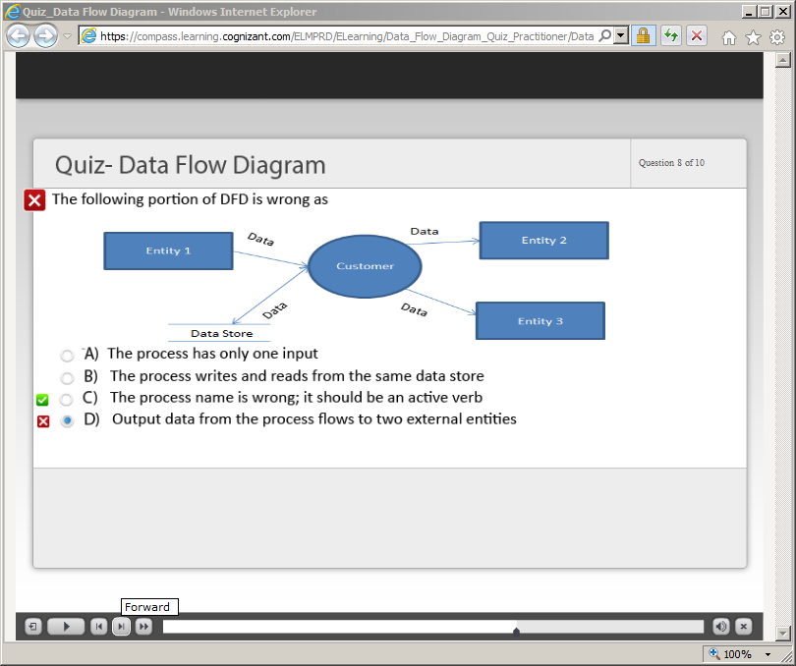](https://compass.learning.cognizant.com/elmprd/elearning/data_flow_diagram_quiz_practitioner/data%20flow%20diagram_quiz_practitioner.htm)

[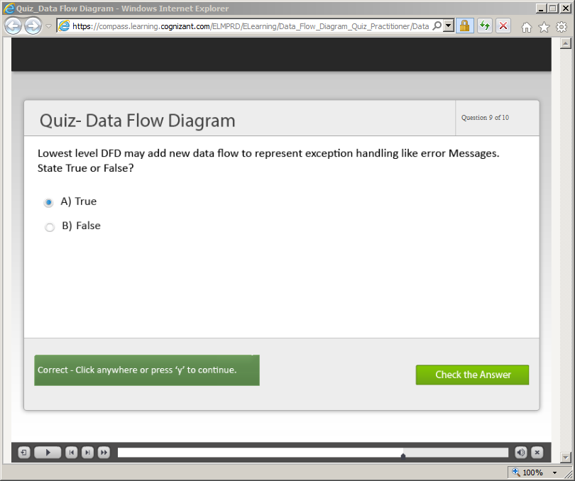](https://compass.learning.cognizant.com/elmprd/elearning/data_flow_diagram_quiz_practitioner/data%20flow%20diagram_quiz_practitioner.htm)

[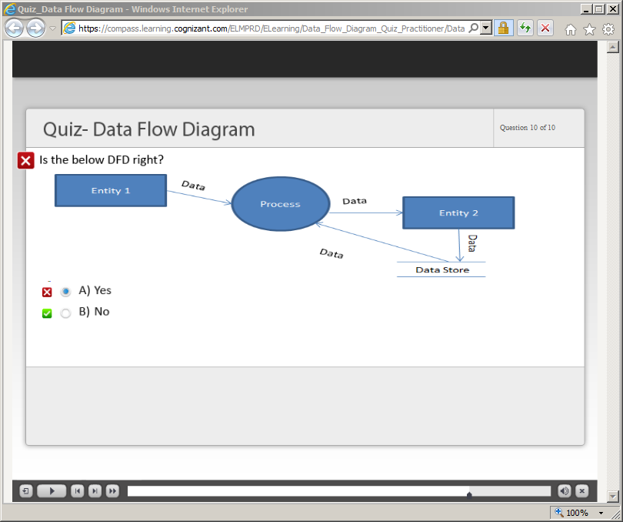](https://compass.learning.cognizant.com/elmprd/elearning/data_flow_diagram_quiz_practitioner/data%20flow%20diagram_quiz_practitioner.htm)